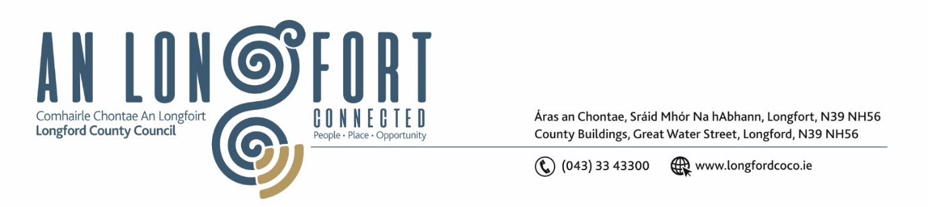**LONGFORD MUNICIPAL DISTRICT**

**Minutes of Meeting of Longford Municipal District held in the Council Chamber Aras an Chontae and via MS Teams on Wednesday, 26 July 2023 at 4pm**

**CATHAOIRLEACH**: Councillor Martin Monaghan

**MEMBERS PRESENT**: Councillors – Uruemu Adejinmi, John Browne, Seamus Butler, Peggy Nolan

**IN ATTENDANCE**: Mr. John Brannigan, Director of Services

Ms. Lorraine McKee, Administrative Officer

Ms. Martina McGrath, Administrative Officer

**MEETINGS**

**ADMINISTRATOR:**  Ms. Claire McNabola

**APOLOGIES:**  Mr. Eamonn Bennett, Senior Executive Engineer

Councillor Gerry Hagan

1. **ADOPTION OF MINUTES – circulated**
2. On the proposal of Councillor Peggy Nolan seconded by Councillor Uruemu Adejinmi it was unanimously agreed to adopt Minutes of Meeting of Longford Municipal District held on the 28 June 2023, as circulated.
3. On the proposal of Councillor Seamus Butler seconded by Councillor Peggy Nolan it was unanimously agreed to adopt Minutes of the Annual Meeting of Longford Municipal District held on the 28 June 2023, as circulated.
4. **MATTERS ARISING FROM MINUTES**

Councillor Butler propose a correction to the minutes, Cllr Butler refereed to revenue from Parking Fees not Parking Fines. This was seconded by Councillor Peggy Nolan

1. **DECLARATION OF INTEREST BY MEMBERS**

None.

1. **MANAGEMENT REPORT - circulated**

The Management Report, as circulated, was noted.

Cllr Browne highlighted the need to look after the raised beds outside of Aras an Chonthae and on Market Square

Cllr Nolan highlighted all the silt that is lying on the ground on the road side, footpaths etc from the rainfall.

1. **CONSIDERATION OF DRAFT LONGFORD APPOINTED STANDS (STREET SERVICE VEHICLES) BYE LAWS 2023 – AS CIRCULATED**

Martina McGrath highlighted the amendments made to the bye laws in respect of Street Service Vehicles. The members shared their views on all of the amendments.

The Managers Report was considered along with feedback from the Roads Department and the following was agreed for adoption:

1. **Schedule 1**-     No change to Permanent Appointed Stands as per Draft Bye Laws which went out to Public Consultation
2. **Schedule 2-**

**2.1** Removal of Main Street (Courthouse) 4 Spaces – for Taxi Use, to be used for General Parking, as no longer in use

**2.2** Extension of Ballymahon Street Taxi Rank, to sufficiently cater for 6 Taxi Spaces – due to Regeneration Build out, only 5 Taxis can park adequately, this rank is to be extended slightly to adequately cater for 6 Taxi Spaces, for occasional use only as per times listed in Draft Bye Laws

On the proposal of Councillor Seamus Butler, seconded by Councillor Uruemu Adejnmi it was unanimously agreed to adopt the draft Longford Appointed Stands (Street Service Vehicles) Bye Laws 2023 as circulated to include agreed additional amendments.

1. **CONSIDERATION OF TAKING IN CHARGE OF ROAD AT PALACE CRESCENT – REPORT CIRCULATED**

On the proposal of Councillor Gerry Warnock, seconded by Councillor Seamus Butler, the members unanimously agreed to the Taking in Charge of road at Palace Crescent, as circulated.

1. **CONSIDERATION OF PART VIII NO. 108 – AGHAFAD PEDESTRIAN AND CYCLIST SCHEME**

On the proposal of Councillor Uruemu Adejnmi, seconded by Councillor John Browne, the members unanimously agreed to the approve the Part VIII application

**NOTICES OF MOTIONS, SUBMITTED BY COUNCILLORS, AS LISTED HEREUNDER:**

**The following notice of motion was proposed by Councillor Gerry Hagan, brought forward by Councillor Peggy Nolan and seconded by Councillor John Browne**

1. I callon Longford MD to carry out road marking reinstatement works on all loading bays in the town. These loading bay markings are worn away and a lot of cars are parking in these loading bays as a result.

**Response**

Longford County Council have contracted a line marking company to reline features such as box junctions, disabled parking spaces, pedestrian crossings and included are loading bays within Longford Town.

**The following notice of motion was proposed by Councillor Gerry Hagan, brought forward by Councillor Peggy Nolan and seconded by Councillor John Browne**

1. I call on Longford MD to install flower boxes on the wide footpath on Main Street outside Kenny’s Shop.  There are a lot of cars and vans parking up on the new path at peak times and this may prevent this from reoccurring.

**Response**

There are double yellow lines in place along the edge of this new section of footpath on main street. Longford County Council will refer the matter to the Traffic Warden with regard to enforcement of the parking bye laws.

Longford County Council have no issue with installing a number of planters at this location however they must be mindful of the ongoing maintenance associated with these planters.

**The following notice of motion was proposed by Councillor Uruemu Adejinmi and seconded by Councillor Seamus Butler**

I call on Longford County Council to look at providing road markings and signage at Derryharrow Cross for the guidance of road users.

**Response**

Longford County Council will arrange to have a road lining company paint a stop bar on both approaches to Derryharrow Cross. In terms of signage there are already stop signs in place on the approach roads to the Cross roads.

**OTHER MATTERS**

Cllr Gerry Warnock requested that a Flag Pole be put in place on Market Square and at all Public Realm locations, John Brannigan advised he would advise the Regeneration Team.

Cllr Martin Monaghan together with all of the Elected Members complimented all the Festival Committees for their time and dedication over the past few weeks and hosting such great events.

This concluded the business of the meeting.

**Signed: ____________________**

**Claire McNabola,**

**Meetings Administrator.**

**Confirmed and adopted at Longford Municipal District Meeting held on the 27 September 2023.**

**Signed: _______________**

**Cathaoirleach.**